University of Washington

iSchool Info 330

# Module 06 Assignment

In this module's assignment, you will learn about how database administrators manage databases and practice what you have learned about the creation of databases.

Note: This assignment will prepare you for the final project.

## Assignment Videos

Please watch the following Videos:

|  |
| --- |
| Assignment Videos < 120 min (Links are to external sites) |
| [How to backup and restore a database - 7](https://youtu.be/PCAw8s9nyX0) |
| [Permission Error when Attaching a database in SQL Server Management Studio - 4](https://youtu.be/LQRUcLt7gPY) |
| [SQL Server Security - 9](https://youtu.be/0wNYR6LZA_o)  [SQL Performance Choices - 7](https://youtu.be/ZuTEHJomtJ8) |
| [Windows Vs SQL Logins - 10](https://youtu.be/loCchzGMxeY) |
| [SQL Server 2016 Part 4 - Databases, Logins, Users, Roles and Schemas - 44](https://youtu.be/IDxXUBNBxPA) |
| [Typical Database Planning Document - 9](https://youtu.be/jIW-tJS3nf8) |

## Assignment Examples

Read and try out some SQL statements on the Microsoft’s website. This website has short articles about many subjects. Although much more complex than the W3Schools website, this website will also become a "Go To" sites as you progress in your learning.

|  |
| --- |
| Examples < 60 min (Links are to external sites) |
| [Introduction](https://www.mssqltips.com/sqlservertutorial/1/sql-server-backup-options-and-commands-tutorial/) |
| [Recovery Models](https://www.mssqltips.com/sqlservertutorial/2/sql-server-recovery-models/) |
| [Full](https://www.mssqltips.com/sqlservertutorial/3/sql-server-full-recovery-model/) |
| Simple |
| Bulk-Logged |
| [Backup Types](https://www.mssqltips.com/sqlservertutorial/6/types-of-sql-server-backups/) |
| Full |
| Transaction Log |
| BACKUP DATABASE |
| BACKUP LOG |
| [SQL indexes](https://www.tutorialspoint.com/sql/sql-indexes.htm) |
| [understanding grant deny and revoke in sql server](https://www.mssqltips.com/sqlservertip/2894/understanding-grant-deny-and-revoke-in-sql-server) |

## Assignment Reading

Since the course does not have an official text you will use various websites for your studies. This is a great way to learn new subjects and practicing it will be something you will use for years to come! Please read the following web pages:

|  |
| --- |
| Reading < 120 min (Links are to external sites) |
| [Authentication in SQL Server](https://docs.microsoft.com/en-us/dotnet/framework/data/adonet/sql/authentication-in-sql-server) |
| [Server and Database Roles in SQL Server](https://docs.microsoft.com/en-us/dotnet/framework/data/adonet/sql/server-and-database-roles-in-sql-server) |
| [Ownership and User-Schema Separation in SQL Server](https://docs.microsoft.com/en-us/dotnet/framework/data/adonet/sql/ownership-and-user-schema-separation-in-sql-server) |
| [Authorization and Permissions in SQL Server](https://docs.microsoft.com/en-us/dotnet/framework/data/adonet/sql/authorization-and-permissions-in-sql-server) |
| [Data Encryption in SQL Server](https://docs.microsoft.com/en-us/dotnet/framework/data/adonet/sql/data-encryption-in-sql-server) |
| [Managing Permissions with Stored Procedures in SQL Server](https://docs.microsoft.com/en-us/dotnet/framework/data/adonet/sql/managing-permissions-with-stored-procedures-in-sql-server) |
| [Application Security Scenarios in SQL Server](https://docs.microsoft.com/en-us/dotnet/framework/data/adonet/sql/application-security-scenarios-in-sql-server) |

## Assignment Task

I would like you to practice what you have learned in the course about the creation of relational databases. To do so, you will write a SQL Script to create a new normalized database with, constraints, views, functions, stored procedures, permissions, and some sample data. As you work on the project, you will use a Meta Data Catalog file to guide you in the creation process. **A starter file called Assignment06.sql has also been provided to get you started.**

The Database will consist of three tables, and you use the design provided in Excel spreadsheet, "***MetaDataWorksheet.xlsx***" to create the database correctly (Figure 1).

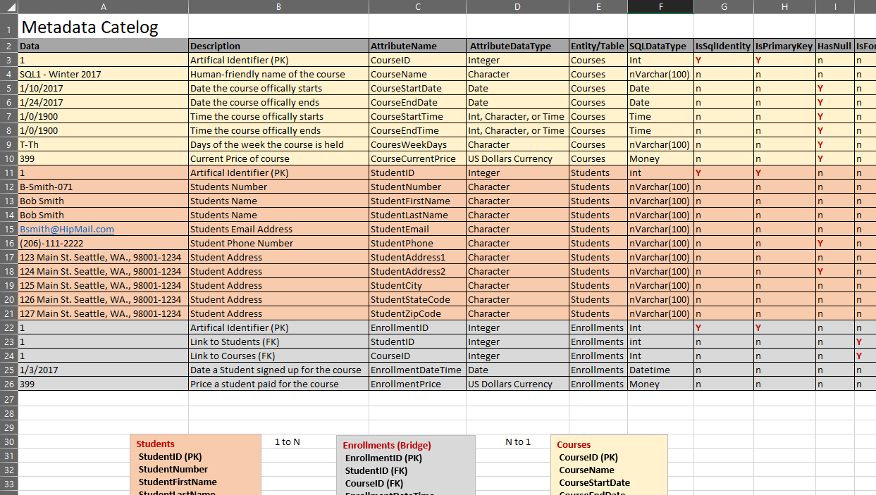

***Figure 1: The metadata tab of the MetaData Worksheet.xlsx file***

The Database will consist of three tables, and you must import the data in the provided Excel spreadsheet, "***MetaDataWorksheet.xlsx.***"

### Task List

Your grade will be based on how well you do on the following tasks (in addition to the general grading rubric!)

1. Create the **database** and **tables**.
2. Create the **constraints** of each tables. This can be done during the table creation if you wish.
3. Create the base **views** for each table.
4. Create one **reporting view** that combines the data for all the tables.
5. Create the **transactional stored procedures** for each table.
6. Set the appropriate **permission** on the tables, views, and stored procedures for the public role.
7. Create **test code** that executes each of the stored procedures and shows the data in the tables.
8. Use your Insert Stored Procedures to **add the data** from the spreadsheet into the tables.

## Assignment Document

Write a document that **describes** the process of designing and creating a relational database.

***Important:*** *Your document must look professional to get full points! Use my example template and video, in the General Files and Topics module, as a guide for what I expect a professional paper to look like. Make sure you format it like a college paper instead of the text message. Things like your name, date, class, citations, introductory and summary paragraphs are always expected! Not putting these in the document you will cost you!*

Here is a link that may help you understand what I am looking for: [Writing Professional Papers](https://youtu.be/9ojhSW9ljjo) (External Site)

# Grading

Student work will be evaluated on a point system using the following general guidelines found on the Course Syllabus page. Make sure you read and understand this.

**NOTE:**  It is very possible to get a 3.9 or better from this course, but you have to earn it! Do not expect to get 100% of the possible points without extra effort on your part. If you want to excel in this course, you must submit **excellent**work!

# Submit your work

After you have completed your Word document and SQL Script, place both into a folder called Assignment06**FirstInitialLastName** and Zip the folder. Upload the Zipped folder to the Canvas web site.

